

USER INTERFACE DESIGN
23CSE113
ASSIGNMENT

SUBMITTED BY
NAME | GOVADA NEHA BHAVANI
ROLL NO | AV.SC.U4CSE25031
YEAR/SEM/SECTION | 1ST YEAR /SEM-2/CSE A
CREDITS | 03

SUBMITTED TO | DR. RAJ KUMAR BATCHU
DESIGNATION | ASST.PROFFESSOR (Sl. Grade)
DEPARTMENT | SCHOOL OF COMPUTING
Assignment
Task : Creation of webpage of railway food ordering website.
Website selected :- https://www.railrestro.com/
Cloning done by me:-
Main webpages HTML code:-
Index.html:-
<!DOCTYPE html>
<html lang="en">
<head>
<meta charset="UTF-8">
<meta name="viewport" content="width=device-width, initial-scale=1.0">
<title>RailRestro Clone</title>
<link rel="stylesheet" href="style.css">
</head>
<body>

<!-- NAVBAR -->
<nav class="navbar">
<div class="logo">railrestro</div>
<ul class="nav-links">
<li><a href="#">LOCATIONS</a></li>
<li><a href="track.html">TRACK ORDER</a></li>
<li><a href="group-order.html">GROUP ORDER</a></li>
<li><a href="jain-food.html">JAIN FOOD</a></li>
<li><a href="login.html">LOGIN</a></li>
</ul>
</nav>

<!-- HERO -->
<section class="hero">
<div class="hero-left">
<h1>Order Delicious Food on Trains Online</h1>
<p>Fresh & Hygienic Food Delivered at Your Train Seat</p>
</div>
<div class="hero-right">
<img src="https://cdn-icons-png.flaticon.com/512/3075/3075977.png">
</div>
</section>

<!-- BOOKING SECTION -->
<section class="booking-section">
<p class="subtitle">
Order Fresh, Delicious & Hygienic Meals Onboard Trains
</p>

<div class="tabs">
<button class="active" id="pnrTab" onclick="showPNR()">
Order Via PNR
</button>

<button id="trainTab" onclick="showTrain()">
Order Via Train No.
</button>
</div>

<div class="booking-box">

<!-- PNR SECTION -->

<div id="pnrSection">
<input
type="text"
id="pnr"
placeholder="Enter 10 Digit PNR No."
onkeyup="loadPNRStations()"
>
<select id="pnrStation">
<option>Select Delivery Station</option>
</select>

<button onclick="placeOrder()">
Order Now
</button>

</div>

<!-- TRAIN SECTION -->

<div id="trainSection" style="display:none;">
<input
type="text"
id="trainNumber"
placeholder="Enter Train No / Train Name"
onkeyup="loadStations()"
>

<input
type="date"
id="boardingDate"
>

<select id="trainStation">

<option>Select Delivery Station</option>

</select>

<button onclick="searchTrain()">
Order Now
</button>

</div>
<p>🎉 3.5 Cr+ meals delivered in trains</p>
</div>
</section>

<!-- FOOD SECTION -->
<section class="food-section">
<h2>Enjoy Hygienic Food on Train</h2>
<div class="food-grid">
<div class="food-card">
<img src="https://images.unsplash.com/photo-1565299624946-b28f40a0ae38">
<h3>Pizza</h3>
<p>Starting ₹199</p>
</div>

<div class="food-card">

<img src="https://images.unsplash.com/photo-1631452180539-96aca7d48617">

<h3>South Indian Meals</h3>

<p>Starting ₹149</p>

</div>

<div class="food-card">
<imgsrc="https://images.unsplash.com/photo-1550547660-d9450f859349">
<h3>Burger Combo</h3>
<p>Starting ₹179</p>
</div>

<div class="food-card">
<imsrc="https://images.unsplash.com/photo-1631515243349-e0cb75fb8d3a">
<h3>Hyderabadi Biryani</h3>
<p>Starting ₹219</p>
</div>

<div class="food-card">
<img src="https://images.unsplash.com/photo-1603894584373-5ac82b2ae398">
<h3>Paneer Butter Masala</h3>
<p>Starting ₹199</p>
</div>

<div class="food-card">
<img src="https://images.unsplash.com/photo-1585032226651-759b368d7246">
<h3>Veg Fried Rice</h3>
<p>Starting ₹169</p>

</div>
</div>
</section>

<!-- FOOTER -->
<footer class="footer">
<h2>railrestro</h2>
<p>Fresh Food Delivery in Trains Across India</p>
<div class="footer-links">
<a href="#">About</a>
<a href="#">Contact</a>
<a href="#">Privacy Policy</a>
</div>
</footer>

<!-- LOADER -->
<div id="loader">
<div class="spinner"></div>
</div>

<script src="script.js"></script>

</body>

</html>

Track.html:-
<!DOCTYPE html>
<html>
<head>
<title>Track Order</title>
<link rel="stylesheet" href="style.css">
</head>
<body>
<section class="track-page">
<h1>Track Your Order</h1>
<div class="track-box">
<input
type="text"
id="orderId"
placeholder="Enter Order ID"
>
<input
type="text"
id="mobile"
placeholder="Enter Mobile Number"
>
<button onclick="trackOrder()">
Track Order
</button>
<div id="orderResult"></div>

</div>
</section>
<script src="script.js"></script>
</body>
</html>

Group-order.html:-
<!DOCTYPE html>
<html>
<head>
<title>Group Order</title>
<link rel="stylesheet" href="style.css">
</head>
<body>
<section class="group-page">
<h1>Group Food Order in Trains Online</h1>
<div class="group-form">
<input type="text" placeholder="Enter Your Name">
<input type="text" placeholder="Enter Mobile Number">
<input type="email" placeholder="Enter Email Address">
<textarea placeholder="Your Query"></textarea>
<button>Send Enquiry</button>
</div>
</section>
</body>
</html>
Jain-food.html:-
<!DOCTYPE html>
<html>
<head>
<title>Jain Food</title>
<link rel="stylesheet" href="style.css">
</head>
<body>
<section class="hero">
<div class="hero-content">
<h1>Jain Food in Train Online</h1>
<div class="order-box">
<input type="text" placeholder="Enter PNR Number">
<button class="order-btn">Order Now</button>
</div>
</div>
</section>
</body>
</html>

Login.html:-
<!DOCTYPE html>
<html lang="en">
<head>
<meta charset="UTF-8">

<meta name="viewport" content="width=device-width, initial-scale=1.0">
<title>RailRestro Login</title>
<link rel="stylesheet" href="style.css">
</head>
<body>
<div class="login-container">
<div class="login-box">
<h1>railrestro</h1>
<p>Login with Mobile Number</p>
<!-- MOBILE INPUT -->
<div id="mobileSection">
<input
type="text"
id="mobile"
placeholder="Enter Mobile Number"
maxlength="10"
>
<button onclick="sendOTP()">
Send OTP
</button>
</div>

<!-- OTP INPUT -->

<div id="otpSection" style="display:none;">
<input
type="text"
id="otp"
placeholder="Enter OTP"
maxlength="4"
>
<button onclick="verifyOTP()">
Login
</button>
</div>
<p id="loginMessage"></p>
</div>
</div>
<script>

let generatedOTP = "";

function sendOTP(){
let mobile =
document.getElementById("mobile").value;
if(mobile.length != 10){
alert("Please Enter Valid Mobile Number");
return;
}

generatedOTP =
Math.floor(1000 + Math.random() * 9000);

alert(
"Demo OTP: " + generatedOTP
);

document.getElementById("otpSection").style.display =
"block";

document.getElementById("loginMessage").innerHTML =
"OTP Sent Successfully ✅";

}
function verifyOTP(){
let otp =
document.getElementById("otp").value;
if(otp == generatedOTP){
localStorage.setItem(
"user",
"LoggedIn"
);
alert("Login Successful 🎉");
window.location.href =
"index.html";

}
else{

alert("Invalid OTP");
}
}
</script>
</body>
</html>

Menu.html:-
<!DOCTYPE html>
<html lang="en">

<head>
<meta charset="UTF-8">
<meta name="viewport" content="width=device-width, initial-scale=1.0">
<title>RailRestro Menu</title>
<link rel="stylesheet" href="style.css">
</head>

<body>

<!-- NAVBAR -->
<nav class="navbar">
<div class="logo">railrestro</div>
<ul class="nav-links">

<li><a href="index.html">HOME</a></li>
<li><a href="track.html">TRACK ORDER</a></li>
<li><a href="profile.html">PROFILE</a></li>
</ul>
</nav>

<!-- TRAIN DETAILS -->

<div class="train-details">
<h2>Train Details</h2>
<div class="train-card" id="trainInfo"></div>
</div>

<!-- DELIVERY STATION -->

<div class="delivery-station">
<h2>Food Delivery Station</h2>
<div class="station-card">
<p id="stationText"></p>
</div>
</div>

<!-- PASSENGER DETAILS -->

<div class="seat-details">
<h2>Passenger Details</h2>
<div class="seat-card" id="seatInfo"></div>
</div>

<!-- FOOD MENU -->
<section class="food-section">
<h2>Popular Food Items</h2>
<div class="food-grid">
<div class="food-card">

<img src="https://images.unsplash.com/photo-1565299624946-b28f40a0ae38">
<h3>Pizza</h3>
<p>₹199</p>
<button onclick="addToCart('Pizza',199)">
Add
</button>
</div>

<div class="food-card">
<img src="https://images.unsplash.com/photo-1631452180539-96aca7d48617">
<h3>South Indian Meals</h3>
<p>₹149</p>
<button onclick="addToCart('South Indian Meals',149)">
Add
</button>
</div>

<div class="food-card">
<img src="https://images.unsplash.com/photo-1631515243349-e0cb75fb8d3a">
<h3>Hyderabadi Biryani</h3>
<p>₹219</p>
<button onclick="addToCart('Hyderabadi Biryani',219)">
Add
</button>
</div>
<div class="food-card">
<img src="https://images.unsplash.com/photo-1585032226651-759b368d7246">
<h3>Veg Fried Rice</h3>
<p>₹169</p>
<button onclick="addToCart('Veg Fried Rice',169)">
Add
</button>
</div>
</div>
</section>

<!-- CART -->
<div class="cart-box">
<h2>Your Cart</h2>
<div id="cartItems"></div>
<h3 id="total">Total: ₹0</h3>
<button onclick="checkout()">
Proceed to Pay
</button>
</div>
<script src="script.js"></script>
</body>
</html>

Profile.html:-
<!DOCTYPE html>
<html>
<head>
<title>User Profile</title>
<link rel="stylesheet" href="style.css">
</head>
<body>
<nav class="navbar">
<div class="logo">railrestro</div>
</nav>
<section class="profile-page">
<div class="profile-card">
<img src="https://cdn-icons-png.flaticon.com/512/3135/3135715.png">
<h2>Neha Bhavani</h2>
<p>📱 +91 9876543210</p>
<p>📧 neha@gmail.com</p>
<button>
Edit Profile
</button>
</div>

<div class="orders-section">
<h2>Recent Orders</h2>
<div class="order-item">

<p><b>Order ID:</b> RR10245</p>
<p>South Indian Meals</p>
<p>₹149</p>
</div>

<div class="order-item">
<p><b>Order ID:</b> RR45892</p>
<p>Hyderabadi Biryani</p>
<p>₹219</p>
</div>
</div>
</section>
</body>
</html>

Script.js:-
function showPNR(){
document.getElementById("pnrSection").style.display = "block";
document.getElementById("trainSection").style.display = "none";
document.getElementById("pnrTab").classList.add("active");
document.getElementById("trainTab").classList.remove("active");
}

function showTrain(){
document.getElementById("pnrSection").style.display = "none";
document.getElementById("trainSection").style.display = "block";
document.getElementById("trainTab").classList.add("active");
document.getElementById("pnrTab").classList.remove("active");
}

/* =========================
PNR STATION LOADING
========================= */

function loadPNRStations(){

let pnr =
document.getElementById("pnr").value;

let station =
document.getElementById("pnrStation");

station.innerHTML =
`<option>Select Delivery Station</option>`;

if(pnr == "6401254789"){
station.innerHTML += `
<option>Secunderabad Junction</option>
<option>Vijayawada Junction</option>
<option>Chennai Central</option>
`;
}

else if(pnr == "8245619374"){
station.innerHTML += `
<option>Bangalore City Junction</option>
<option>Nagpur Junction</option>
<option>New Delhi</option>
`;
}

else if(pnr == "7319456821"){
station.innerHTML += `
<option>Mumbai Central</option>
<option>Vadodara Junction</option>
<option>Kota Junction</option>
`;
}

else if(pnr.length == 10){
station.innerHTML += `
<option>Hyderabad Junction</option>
<option>Warangal Junction</option>
<option>Delhi Junction</option>
`;
}
}

/* =========================
TRAIN STATION LOADING
========================= */

function loadStations(){

let train =
document.getElementById("trainNumber").value;

let station =
document.getElementById("trainStation");

station.innerHTML =
`<option>Select Delivery Station</option>`;

if(train == "12760"){
station.innerHTML += `
<option>Secunderabad Junction</option>
<option>Kazipet Junction</option>
<option>Vijayawada Junction</option>
<option>Chennai Central</option>
`;
}

else if(train == "12627"){
station.innerHTML += `
<option>Bangalore City Junction</option>
<option>Nagpur Junction</option>
<option>Jhansi Junction</option>
<option>New Delhi</option>
`;
}

else if(train == "12951"){
station.innerHTML += `
<option>Mumbai Central</option>
<option>Vadodara Junction</option>
<option>Kota Junction</option>
<option>New Delhi</option>
`;
}

else if(train.length >= 5){
station.innerHTML += `
<option>Hyderabad Junction</option>
<option>Warangal Junction</option>
<option>Delhi Junction</option>
`;
}
}

/* =========================
PNR ORDER
========================= */

function placeOrder(){

let pnr =
document.getElementById("pnr").value;

let station =
document.getElementById("pnrStation").value;

if(pnr.length != 10){
alert("Please Enter Valid 10 Digit PNR");
return;
}

if(station == "Select Delivery Station"){
alert("Please Select Delivery Station");
return;
}

if(pnr == "6401254789"){
localStorage.setItem("trainNo","12760");
}

else if(pnr == "8245619374"){
localStorage.setItem("trainNo","12627");
}

else if(pnr == "7319456821"){
localStorage.setItem("trainNo","12951");
}

else{
localStorage.setItem("trainNo","12049");
}

localStorage.setItem("station",station);
localStorage.setItem("date","2026-05-12");
window.location.href = "menu.html";
}
/* =========================
TRAIN ORDER
========================= */

function searchTrain(){

let train =
document.getElementById("trainNumber").value;

let station =
document.getElementById("trainStation").value;

let date =
document.getElementById("boardingDate").value;

if(train == ""){
alert("Please Enter Train Number");
return;
}

if(station == "Select Delivery Station"){
alert("Please Select Delivery Station");
return;
}

if(date == ""){
alert("Please Select Boarding Date");
return;
}

localStorage.setItem("trainNo",train);
localStorage.setItem("station",station);
localStorage.setItem("date",date);
window.location.href = "menu.html";
}

/* =========================
MENU PAGE
========================= */

window.onload = function(){
let train =
localStorage.getItem("trainNo");

let station =
localStorage.getItem("station");

let date =
localStorage.getItem("date");

/* TRAIN DETAILS */

if(document.getElementById("trainInfo")){
if(train == "12760"){
document.getElementById("trainInfo").innerHTML = `
<p><b>Train:</b> 12760 - Charminar Express</p>
<p><b>From:</b> Hyderabad</p>
<p><b>To:</b> Chennai</p>
<p><b>Current Station:</b> Vijayawada Junction</p>
<p><b>Date:</b> ${date}</p>
`;
}

else if(train == "12627"){
document.getElementById("trainInfo").innerHTML = `
<p><b>Train:</b> 12627 - Karnataka Express</p>
<p><b>From:</b> Bangalore</p>
<p><b>To:</b> Delhi</p>
<p><b>Current Station:</b> Nagpur Junction</p>
<p><b>Date:</b> ${date}</p>
`;
}
else if(train == "12951"){
document.getElementById("trainInfo").innerHTML = `
<p><b>Train:</b> 12951 - Mumbai Rajdhani</p>
<p><b>From:</b> Mumbai</p>
<p><b>To:</b> Delhi</p>

<p><b>Current Station:</b> Kota Junction</p>
<p><b>Date:</b> ${date}</p>
`;
}

else{
document.getElementById("trainInfo").innerHTML = `
<p><b>Train:</b> ${train}</p>
<p><b>Train Name:</b> Superfast Express</p>
<p><b>From:</b> Hyderabad</p>
<p><b>To:</b> Delhi</p>
<p><b>Date:</b> ${date}</p>
`;
}
}

/* PASSENGER DETAILS */
if(document.getElementById("seatInfo")){
let passengers = [
"Neha",
"Rahul",
"Anjali",
"Arjun",
"Kiran",
"Ravi"
];

let coaches = [
"S1",
"S2",
"S3",
"B1",
"B2",
"A1"
];

let randomPassenger =
passengers[
Math.floor(Math.random()*passengers.length)
];

let randomCoach =
coaches[
Math.floor(Math.random()*coaches.length)
];

let randomSeat =
Math.floor(Math.random()*72)+1;

document.getElementById("seatInfo").innerHTML = `
<p><b>Passenger:</b> ${randomPassenger}</p>

<p><b>Coach:</b> ${randomCoach}</p>
<p><b>Seat Number:</b> ${randomSeat}</p>
<p><b>Boarding Station:</b> ${station}</p>
`;
}

/* DELIVERY STATION */
if(document.getElementById("stationText")){
document.getElementById("stationText").innerHTML =
"📍 Food will be delivered at: <b>" +
station +
"</b>";
}
}

/* =========================
CART
========================= */

let total = 0;
function addToCart(item,price){
let cart =
document.getElementById("cartItems");
cart.innerHTML +=
`<p>${item} - ₹${price}</p>`;

total += price;
document.getElementById("total").innerHTML =
"Total: ₹" + total;
}

function checkout(){
if(total == 0){
alert("Please Select Food Items");
return;
}
alert(
"Order Placed Successfully! 🎉\n\n" +
"Total Amount: ₹" + total
);
}

Style.css:-
*{
margin:0;
padding:0;
box-sizing:border-box;
font-family:Arial, sans-serif;
}

body{
background:#f4f4f4;
}

/* NAVBAR */

.navbar{
width:100%;
height:90px;
background:white;
display:flex;
justify-content:space-between;
align-items:center;
padding:0 80px;
box-shadow:0 2px 10px rgba(0,0,0,0.08);
}

.logo{
font-size:52px;
color:#ff5a00;
font-weight:bold;
}

.nav-links{
display:flex;
gap:35px;
list-style:none;
}

.nav-links a{
text-decoration:none;
color:#4b4bff;
font-size:17px;
font-weight:600;
}

/* HERO SECTION */

.hero{
width:100%;
min-height:320px;
background:
linear-gradient(rgba(0,0,0,0.4),rgba(0,0,0,0.4)),
url("https://images.unsplash.com/photo-1474487548417-781cb71495f3");
background-size:cover;
background-position:center;
display:flex;
justify-content:space-between;
align-items:center;
padding:50px 120px;
color:white;

}

.hero-left h1{
font-size:56px;
line-height:1.3;
}

.hero-left p{
font-size:22px;
margin-top:15px;
}

.hero-right img{
width:240px;
animation:float 3s ease-in-out infinite;
}
@keyframes float{

0%{
transform:translateY(0px);
}

50%{
transform:translateY(-15px);
}

100%{
transform:translateY(0px);
}

}

/* BOOKING SECTION */

.booking-section{
width:100%;
text-align:center;
padding:60px 20px;
}
.subtitle{
font-size:20px;
color:#444;
margin-bottom:25px;
}
.tabs{
display:flex;
justify-content:center;
}
.tabs button{
padding:16px 35px;
border:none;
background:white;
font-size:18px;
cursor:pointer;
color:#555;
font-weight:600;
}
.tabs .active{
background:#ff5a00;
color:white;
border-radius:12px 12px 0 0;
}
.booking-box{
width:60%;
background:white;
margin:auto;
padding:40px;
border-radius:0 0 20px 20px;
box-shadow:0 4px 15px rgba(0,0,0,0.1);
}
.booking-box input{
width:100%;
padding:18px;
margin-bottom:20px;
border-radius:10px;
border:1px solid #ccc;
font-size:18px;
}

.booking-box button{
width:100%;
padding:18px;
background:#ff5a00;
color:white;
border:none;
border-radius:10px;
font-size:20px;
font-weight:bold;
cursor:pointer;
transition:0.3s;
}
.booking-box button:hover{
background:#d63b00;
}
.booking-box p{
margin-top:20px;
font-size:18px;
color:#444;
}

/* FOOD SECTION */

.food-section{
padding:70px 100px;
}

.food-section h2{
text-align:center;
font-size:44px;
margin-bottom:40px;
color:#333;
}
.food-grid{
display:grid;
grid-template-columns:repeat(3,1fr);
gap:30px;
}
.food-card{
background:white;
border-radius:18px;
overflow:hidden;
box-shadow:0 4px 15px rgba(0,0,0,0.1);
transition:0.3s;
text-align:center;
padding-bottom:20px;
}
.food-card h3{
margin-top:15px;
font-size:24px;
}

.food-card p{
margin-top:10px;
color:#ff5a00;
font-size:18px;
font-weight:bold;
}
.food-card:hover{
transform:translateY(-10px);
}
.food-card img{
width:100%;
height:240px;
object-fit:cover;
display:block;
}

/* TRACK ORDER PAGE */

.track-page{
padding:70px 20px;
min-height:100vh;
}
.track-page h1{
text-align:center;
font-size:48px;
color:#ff5a00;
margin-bottom:40px;
}
.track-box{
width:520px;
margin:auto;
background:white;
padding:40px;
border-radius:20px;
box-shadow:0 4px 15px rgba(0,0,0,0.1);
}
.track-box input{
width:100%;
padding:18px;
margin-bottom:20px;
border-radius:10px;
border:1px solid #ccc;
font-size:18px;
}
.track-box button{
width:100%;
padding:18px;
background:#ff5a00;
color:white;
border:none;
border-radius:10px;
font-size:20px;
cursor:pointer;
}
#orderResult{
margin-top:25px;
background:#fff4ef;
padding:20px;
border-radius:10px;
font-size:18px;
line-height:1.8;
}

/* GROUP ORDER PAGE */

.group-page{
padding:70px 20px;
background:#fff8f4;
min-height:100vh;
}
.group-page h1{
text-align:center;
color:#ff5a00;
font-size:46px;
margin-bottom:40px;
}
.group-form{
width:650px;
margin:auto;
background:white;
padding:40px;
border-radius:20px;
box-shadow:0 4px 15px rgba(0,0,0,0.1);
}
.group-form input,
.group-form textarea{
width:100%;
padding:18px;
margin-bottom:20px;
border-radius:10px;
border:1px solid #ccc;
font-size:18px;
}
.group-form textarea{
height:130px;
resize:none;
}
.group-form button{
width:100%;
padding:18px;
background:#ff5a00;
color:white;
border:none;
border-radius:10px;
font-size:20px;
cursor:pointer;
}

/* JAIN FOOD PAGE */

.jain-page{
min-height:100vh;
background:linear-gradient(to right,#ff5a00,#d63b00);
padding:90px 20px;
text-align:center;
color:white;
}
.jain-page h1{
font-size:54px;
margin-bottom:20px;
}
.jain-page p{
font-size:22px;
margin-bottom:40px;
}
.jain-box{
width:550px;
margin:auto;
background:white;
padding:40px;
border-radius:20px;
color:black;
}
.jain-box input{
width:100%;
padding:18px;
margin-bottom:20px;
border-radius:10px;
border:1px solid #ccc;
font-size:18px;
}
.jain-box button{
width:100%;
padding:18px;
background:#ff5a00;
color:white;
border:none;
border-radius:10px;
font-size:20px;
cursor:pointer;
}

/* LOGIN PAGE */

.login-page{
min-height:100vh;
padding:80px 20px;
background:#f8f8f8;
}
.login-container{
height:100vh;
display:flex;
justify-content:center;
align-items:center;
background:#f5f5f5;
}
.login-box{
width:350px;
background:white;
padding:30px;
border-radius:15px;
box-shadow:0 5px 20px rgba(0,0,0,0.1);
text-align:center;
}
.login-box h1{
color:#ff5a00;
margin-bottom:10px;
}

.login-box input{
width:100%;
padding:12px;
margin-top:15px;
border:1px solid #ccc;
border-radius:10px;
font-size:16px;
}
.login-box button{
width:100%;
padding:12px;
margin-top:15px;
border:none;
border-radius:10px;
background:#ff5a00;
color:white;
font-size:16px;
cursor:pointer;
}
.login-box button:hover{
background:#ff5a00;
}

/* MOBILE RESPONSIVE */
@media(max-width:900px){

.navbar{
flex-direction:column;
height:auto;
padding:20px;
}
.nav-links{
flex-wrap:wrap;
justify-content:center;
margin-top:20px;
}
.hero{
flex-direction:column;
text-align:center;
padding:50px 20px;
}
.hero-left h1{
font-size:38px;
}
.hero-right img{
width:170px;
margin-top:30px;
}
.booking-box{
width:95%;
}
.food-section{
padding:40px 20px;
}

.food-grid{
grid-template-columns:1fr;
}
.track-box,
.group-form,
.jain-box,
.login-box{
width:100%;
}
.track-page h1,
.group-page h1,
.jain-page h1,
.login-page h1{
font-size:34px;
}
}

.navbar{
position:sticky;
top:0;
z-index:1000;
}
html{
scroll-behavior:smooth;
}

.footer{
background:#1e1e1e;
color:white;
text-align:center;
padding:50px 20px;
}
.footer h2{
font-size:42px;
color:#ff5a00;
}
.footer p{
margin-top:15px;
font-size:18px;
}
.footer-links{
margin-top:20px;
}
.footer-links a{
color:white;
margin:0 15px;
text-decoration:none;
}
#loader{
position:fixed;
width:100%;
height:100%;
background:white;
display:flex;
justify-content:center;
align-items:center;
z-index:9999;
}
.spinner{
width:60px;
height:60px;
border:6px solid #eee;
border-top:6px solid #ff5a00;
border-radius:50%;
animation:spin 1s linear infinite;
}
@keyframes spin{
100%{
transform:rotate(360deg);
}
}

.cart-box{
width:500px;
margin:50px auto;
background:white;
padding:30px;
border-radius:20px;
box-shadow:0 4px 15px rgba(0,0,0,0.1);
}
.cart-box h2{
margin-bottom:20px;
}
.cart-box button{
width:100%;
padding:16px;
margin-top:20px;
background:#ff5a00;
color:white;
border:none;
border-radius:10px;
font-size:18px;
cursor:pointer;
}
.train-details{
width:70%;
margin:40px auto;
}
.train-card{
background:white;
padding:30px;
border-radius:20px;
box-shadow:0 4px 15px rgba(0,0,0,0.1);
line-height:2;
font-size:18px;
}
.booking-box select{
width:100%;
padding:18px;
margin-bottom:20px;
border-radius:10px;
border:1px solid #ccc;
font-size:18px;
background:white;
}
.seat-details{
width:70%;
margin:40px auto;
}
.seat-card{
background:white;
padding:30px;
border-radius:20px;
box-shadow:0 4px 15px rgba(0,0,0,0.1);
line-height:2;
font-size:18px;
}
.profile-page{
padding:70px 20px;
}
.profile-card{
width:400px;
margin:auto;
background:white;
padding:40px;
border-radius:20px;
text-align:center;
box-shadow:0 4px 15px rgba(0,0,0,0.1);
}
.profile-card img{
width:120px;
}
.profile-card h2{
margin-top:20px;
font-size:32px;
}
.profile-card p{
margin-top:15px;
font-size:18px;
}
.profile-card button{
margin-top:25px;
padding:15px 30px;
border:none;
background:#ff5a00;
color:white;
border-radius:10px;
cursor:pointer;
}
.orders-section{
width:70%;
margin:60px auto;
}
.order-item{
background:white;
padding:25px;
margin-top:20px;
border-radius:15px;
box-shadow:0 4px 10px rgba(0,0,0,0.1);
}
.delivery-station{
width:70%;
margin:30px auto;
}
.station-card{
background:white;
padding:25px;
border-radius:18px;
box-shadow:0 4px 15px rgba(0,0,0,0.1);
font-size:20px;
}

Output:-
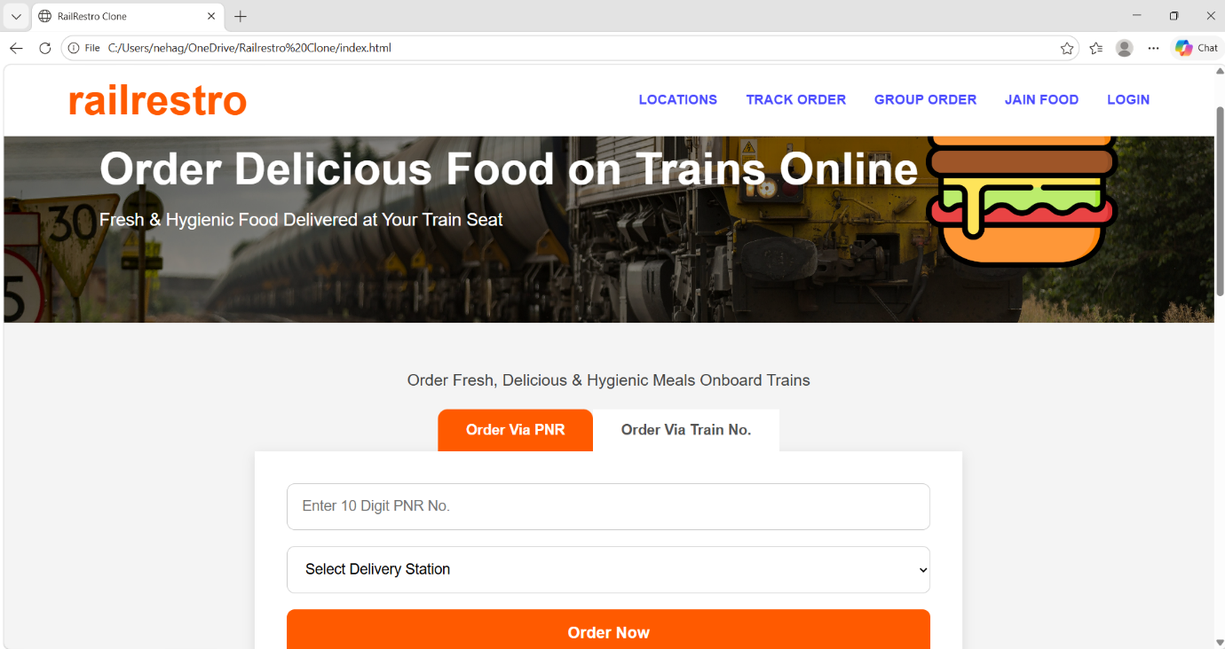

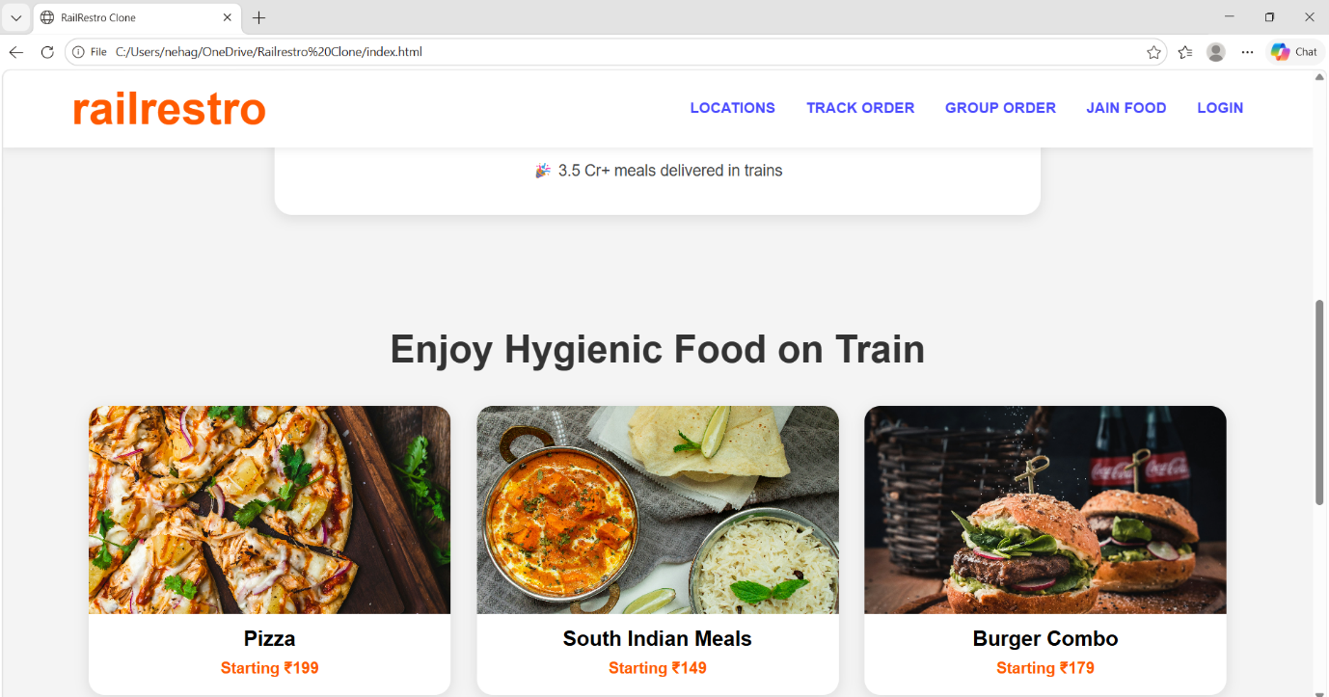
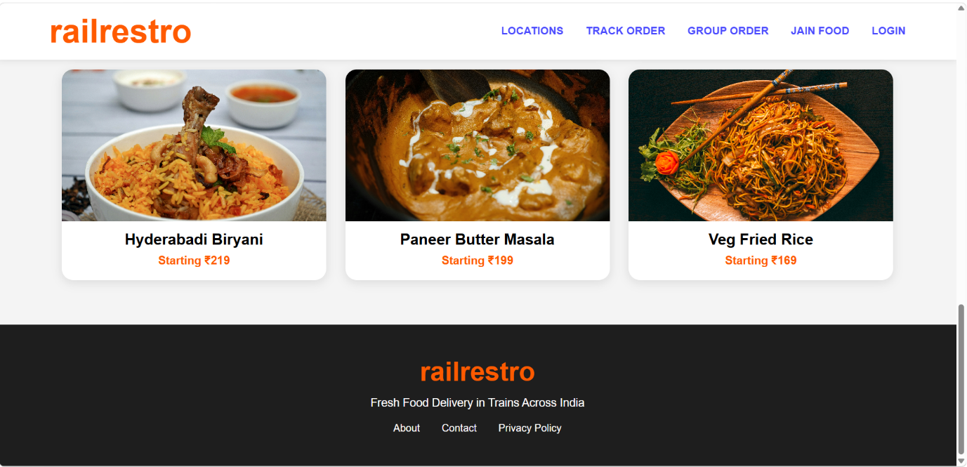
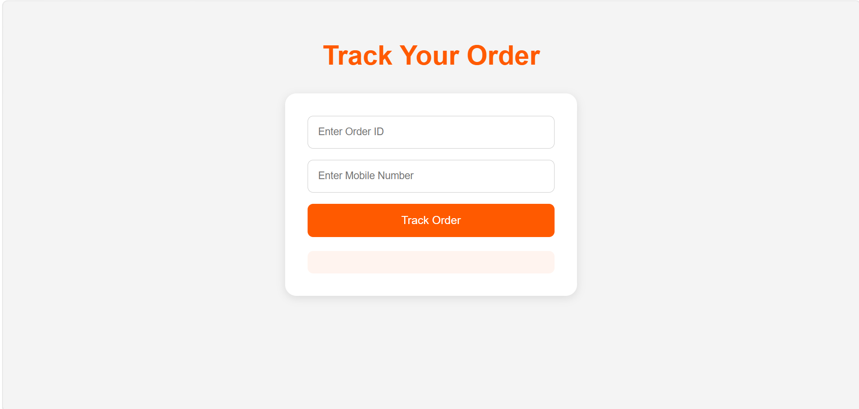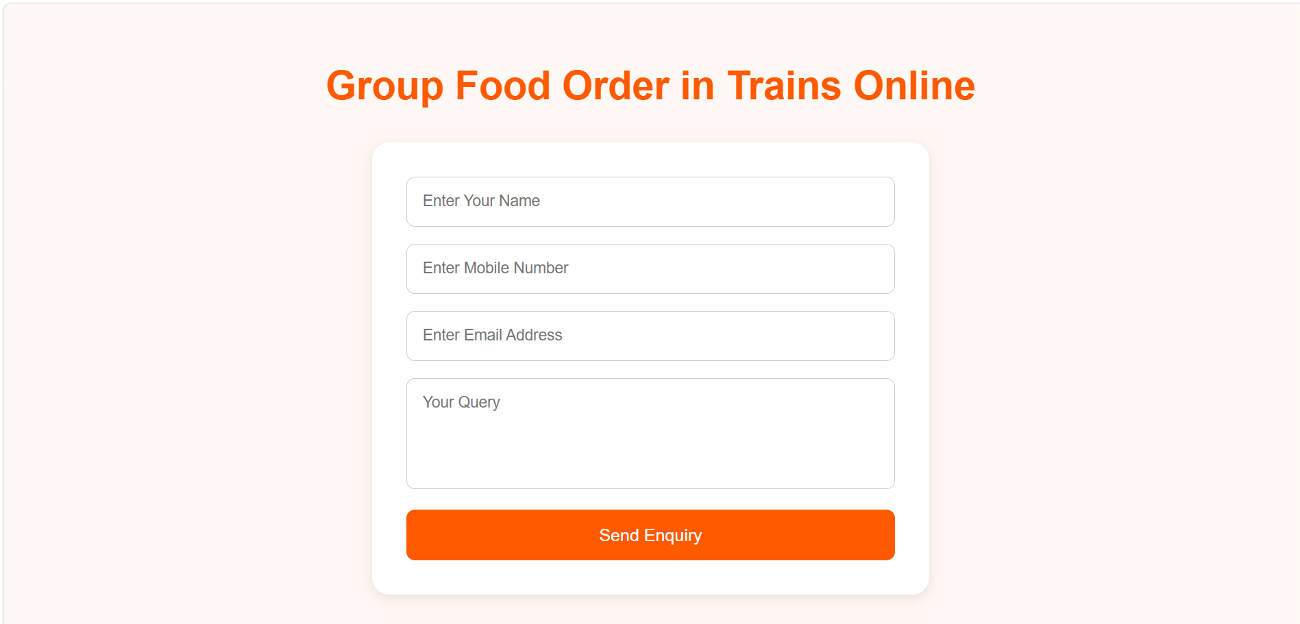

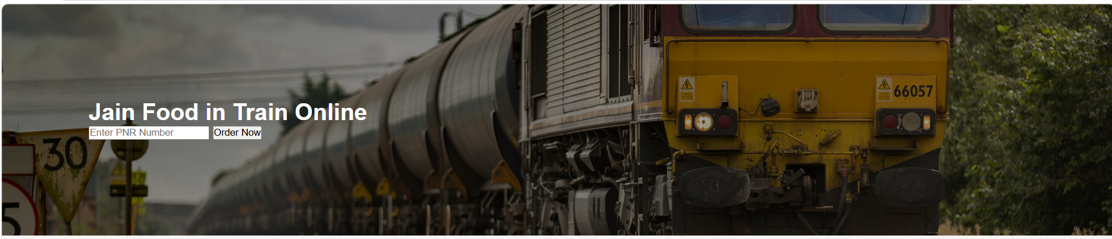
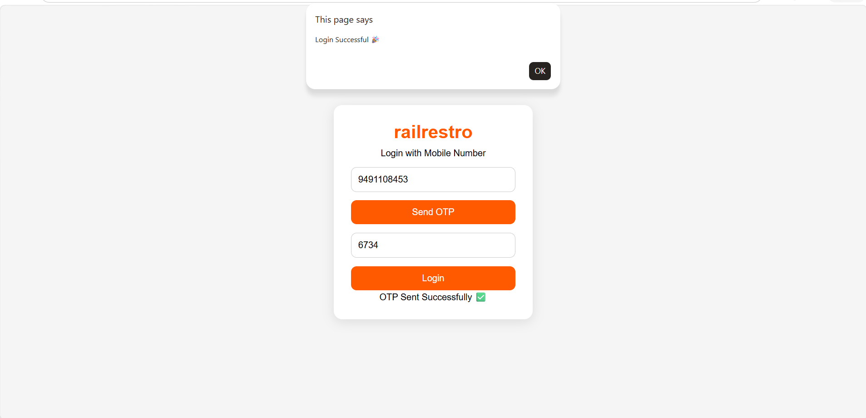

To order on PNR Number:
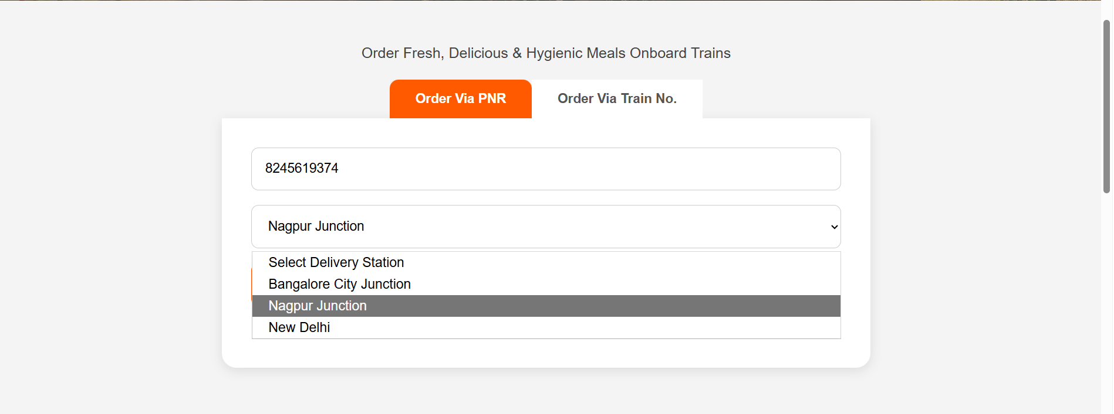
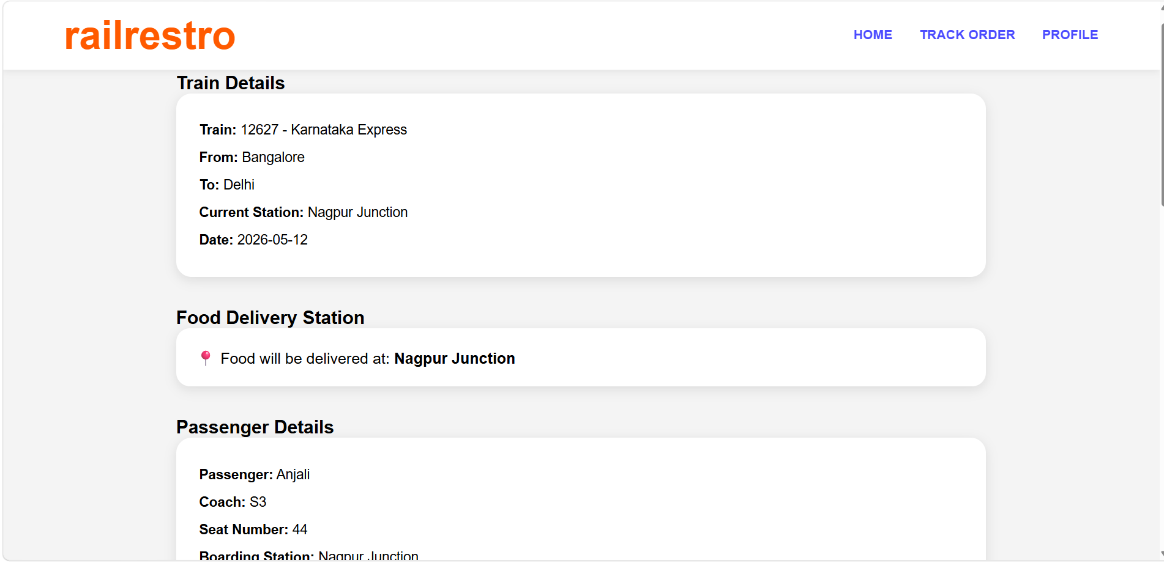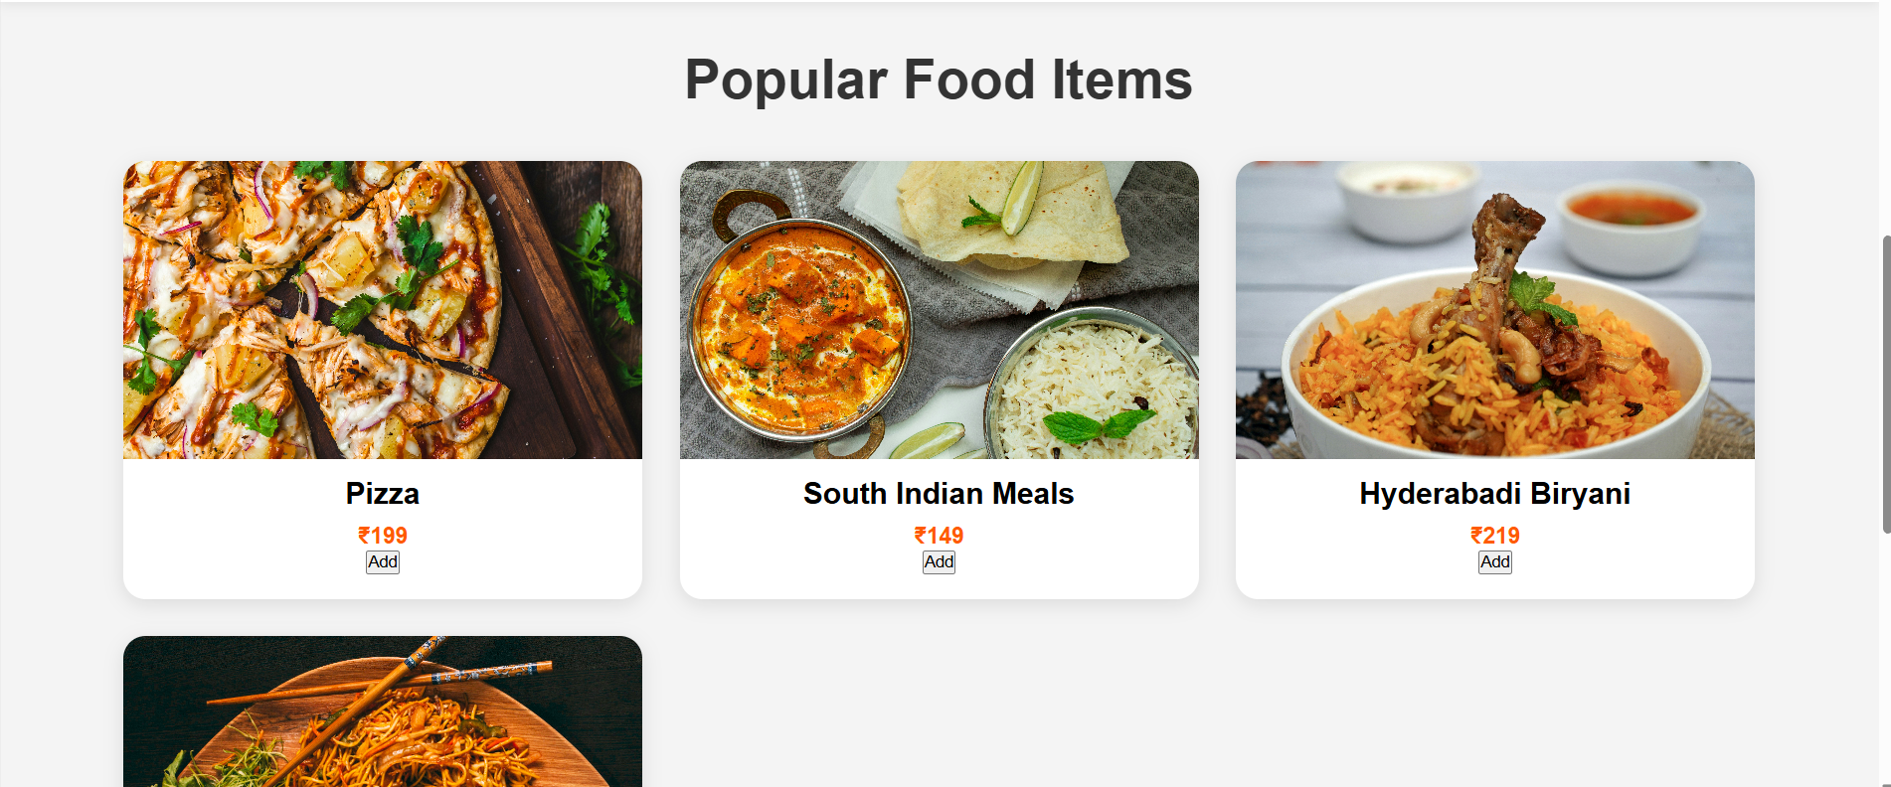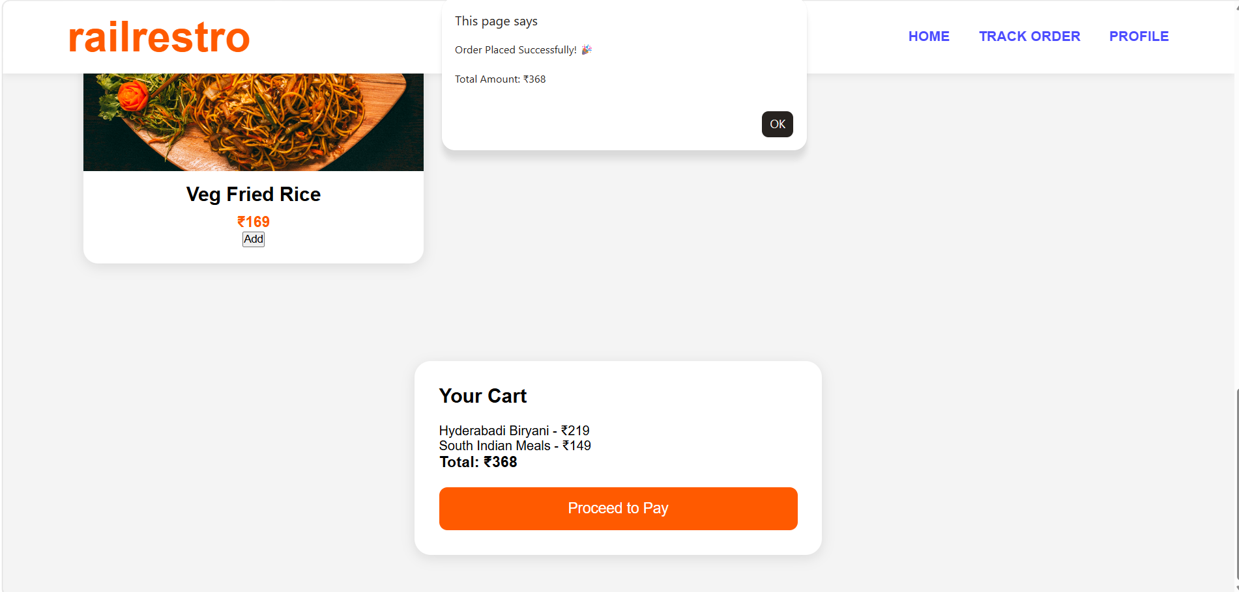

To Order on Train No:-
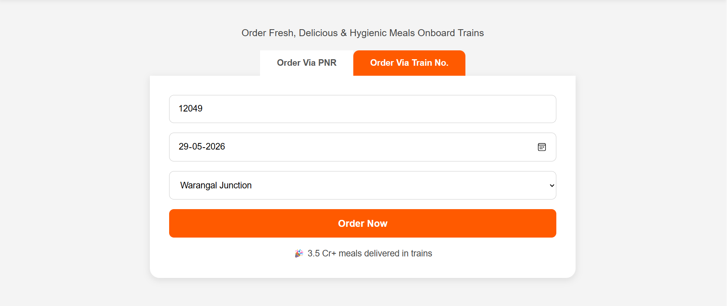
Explanation of Tags:
<meta charset="UTF-8">
- Supports all characters and symbols.
<button onclick="placeOrder()">
- Onclick – Calls JavaScript function when clicked.
<input> - Used to get user input.
Onkeyup – Runs JavaScript when user types.
<select> - Creates dropdown menu.
<option> - Dropdown options.
<div class="food-card"> - Creates separate food item cards.
<footer> - Defines bottom section of webpage.
<script> - Contains JavaScript file.
placeholder="Enter 10 Digit PNR No." – Shows hint text inside input box.
<div> - Used to group elements together.
<nav> - Creates navigation bar.
<ul> - Creates unordered list.
<li> - Represents list items.
<section> - Defines a webpage section.
<meta name="viewport" content="width=device-width, initial-scale=1.0"> - Makes website mobile- friendly.

